Study Inclusion / Selection & Graphics with ggplot2
Once again, the files you need to submit are your R script and this document in word or PDF by 11:59pm on the due date. Paste in your code and output into this document where it is specifically requested. If directions are given but nothing is asked directly, an “OK” response will suffice. Name your files following this convention (where X is the number of the HW) and email them to Mike:
epid799b_hwX_lastname.pdf (Homework document with answers filled in)
epid799b_hwX_lastname.r (R script).
Readability. A reminder, please, for your sake and the instructor’s, make efforts to comment, create code blocks, and write legible code. However, on answering questions in this document, please write as little as you can – short answers and sentence fragments are encouraged.
Recoding. Homework 2 extends on the work of homework 1, meaning these scripts should be built on top of the recoded variables from homework 1. Please update your HW 1 looking at the released HW 1
Complete the follow steps in R/RStudio:

Part 1: Subset for our study inclusion criteria

- Create useful calculated variables
  - Week number: Create the weeknum variable in the births dataset using the week() function in lubridate and the date of birth (dob) variable in already in.

- Create simple exclusion variables
We will now exclude births from the study to simplify and hone our research question. Specifically, we’ll look at births that have data on our variables of interest, had all their weeks of gestation at risk of preterm birth within our study year, are single births, and have no congenital anomalies. In each case we’ll create a variable starting with “incl_” in the dataset so we can keep track of various criteria for study inclusion, with the variable = 1 meaning it passes that inclusion test, and 0 meaning it does not pass. We’ll use *apply() functions where helpful to help reduce our code. The as.numeric() function may be helpful to cast Booleans to 1s and 0s, though T and F are interpreted intelligently as 1 and 0 as well – these instructions are based on 1s and 0s, but you may use T and F if that makes more sense to you.

  - Has Gestation: Create incl_hasgest in the births dataset to be a 1 if the birth has wksgest data, 0 if missing.
  - Enough gest: Create incl_enoughgest in the births dataset to be a 1 if the birth has >= 20 weeks of gestation, 0 if otherwise.
  - Late enough: Create incl_lateenough to be 1 when wksgest-weeknum <= 19, 0 otherwise.
  - Early enough: Create incl_earlyenough to be 1 when weeknum - wksgest <= 7, 0 otherwise.
  - Singletons: Create incl_singleton to be 1 when plur is 1, 0 otherwise.

- Create congenital anomaly variable using apply()
There is no single “has congenital anomaly” variable, so we’ll need to create one. Some hints: Use the MARGIN parameter of apply() to decide between rows and columns (we’ll want rows). The dataframe to pass to apply() will need to be subsetted to just the congen_anom variables. It may be easiest to send that dataframe into apply() as all Booleans (e.g. df[subsetting-goes-here] ==”N”).
  - Create name vector: Create a variable congen_anom (outside births) to be equal to a vector of the names of congenital anomaly variables. You would normally refer to the meta data, but to save you typing, here are those variables:
"anen","mnsb","cchd", "cdh", "omph","gast", "limb", "cl","cp","dowt","cdit", "hypo"
  - Check all anomalies at once: Use apply() with the all() function on the congenital anomaly columns of births to return a 1 if all congenital anomaly variables are “N”, 0 otherwise and assign it to variable incl_noanomalies.
- Finish the inclusion criteria
  - Save your dataset pre-subsetting as old_births. If you need to, you can birth=old_births (sometimes I’ll save these sorts of save points in a comment... ).
  - (Optional Challenge): In one line of R, report the number that failed each inclusion test using apply() and sum over the column margins instead of rows.
  - Check all inclusion critieria and subset: Using the grepl() function to find just the variables with incl_ in their name, subset births to be just those that have a 1 in every incl_ variable. This is similar to what’s done in 3b, above, but we’re subsetting on the outcome of the apply
  - Summarize exclusion: Report the number of births before and after the inclusion criteria using nrow() or dim().

- Optional Challenge: Create an “any exclusion” variable in oldbirths (before we subset it). Use tableone grouped by that variable to describe the difference in the exclusion and inclusion cohorts.

Part 2: Create some tables and graphs describing the new dataset
and ensuring the inclusion criteria worked
- Mimic Graphs: Mimic these graphs as best you can using ggplot2 and paste them in below each graph. If they aren’t exact, that’s fine! Optional Challenge: Add meaningful color to these plots by creating an explicitly or implicitly stat-transformed dataset (e.g. if implicit, using ..prop.. or ..count.. color).
  - 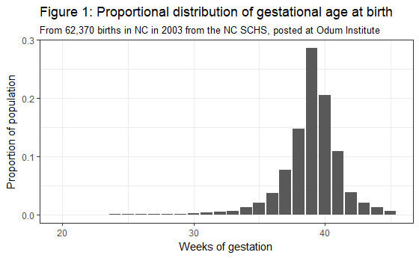
  - 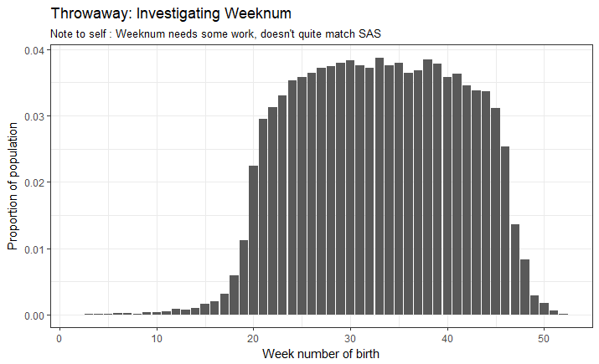
  - 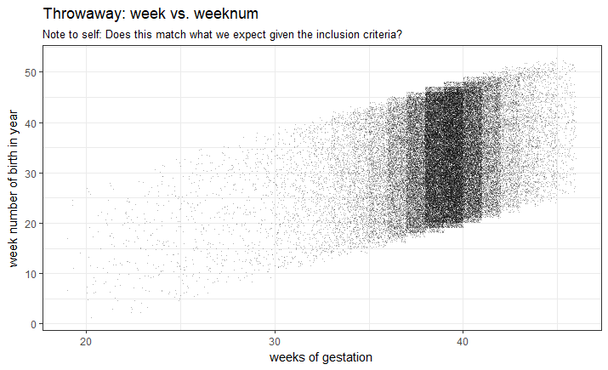
  - Create your own! Create and submit any ggplot2 graphic you like built from the births dataset and using our variables of interest. Use at least two geometry layers, a title, a subtitle, and a caption that describes your interpretation of the punchline of your graph.
Note that we do not yet have tools to dramatically transform the dataframe (one more week!), so you may You may or may not need to transform your data in order to make your planned map

