Creating & graphing summary / exploratory datasets with dplyr and ggplot
Once again, the files you need to submit are your R script and this document in word or PDF by 11:59pm on the due date. Paste in your code and output into this document where it is specifically requested. If directions are given but nothing is asked directly, an “OK” response will suffice. Name your files following this convention (where X is the number of the HW) and email them to Mike:
epid799b_hwX_lastname.pdf (Homework document with answers filled in)
epid799b_hwX_lastname.r (R script).
Readability. A reminder, please, for your sake and the instructor’s, make efforts to comment, create code blocks, and write legible code. However, on answering questions in this document, please write as little as you can – short answers and sentence fragments are encouraged.
Recoding. Homeworks 2 through 5 extend on the preceding homework, so please build this onto the foundation build previously (e.g. recoding, etc.). If necessary, update your preceding homework sections with the released answers.
Complete the follow steps in R/RStudio:

Part 1: Functional form of mage with dplyr

- Create a summary table for maternal age: Using dplyr, create a summary table for mage from the births dataset whose head looks like below: 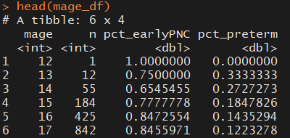

- Explore functional form: Great a ggplot similar to the below plot that demonstrates the functional form of maternal age to the risk of preterm birth. Note that the “weight” aesthetic will be important so that the larger center bins appropriately pull most of the quick loess model. I would consider the “on the fly” linear square term model to be a challenge – if you want to attempt it, check the help page for geom_smooth, looking at the method and formula parameters.
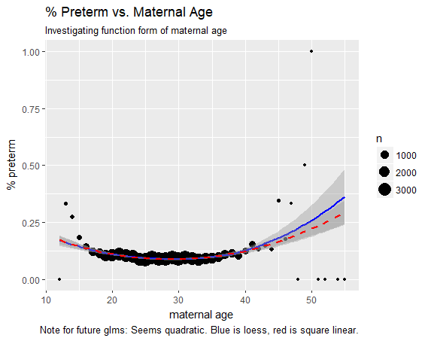

Part 2: County-specific stories
- Create a County Summary Table: Using similar dplyr techniques, we’ll create a county table. In this case we’ll also read in a helper table and do some work with it.
  - Read in birth format helper 2012.csv. Using base R we’ve learned previously, perform these tasks to convert it to a table called county_data:
    - Filter to just include rows where variable is cores
    - Rename the columns to variable, cores, county_name and FIPS
    - Drop the “variable” column
    - Covert cores to a number if it is a character (check with str()!)

  - Using dplyr and pipes, complete the same tasks to create county_data from format_helper in “one line” (even if you indent it). You’ll need the filter(), rename(), select() and mutate() functions.
  - Download and read in county_tiers.csv into a county_tiers data.frame from the NC Department of Commerce (https://www.nccommerce.com/research-publications/incentive-reports/county-tier-designations). For convenience, the csv is available on the course website. Note the “ordered” factor variable econ_tier – convert econ-tier from integer to a factor using ordered() or factor() with the right parameters.

  - In one dplyr statement, create county_df data.frame that has its head() like below. You’ll need group_by(), summarize() (with n()!), and two left_join().
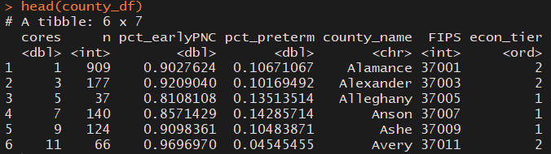

  - Write the data.frame you’ve created to a local file called “county_birth_summary.csv” We may use it later.

- Create a ggplot (and paste in here) that describes the relationship between the percent of our exposure, outcome, and economic tier of the county. There are many ways to do this! (Challenge: you might consider using plotly package to “hand” explore this interesting summary dataset.)

- Challenge: dplyr gather() and ordered factors.
Use dplyr gather() to create a data.frame that turns our variables n, pct_earlyPNC and pct_preterm into variables where the name is in one column and the value in another. Create an ordered factor county_name_ord that’s ordered by the pct_earlyPNC variable – this factor will specify the plot order. Use the variable to facet your ggplot and produce something similar to below. This is just a few lines of R, but definitely a challenge. This is not the best way to map these aesthetics to answer this question; the point of the challenge is in ordered factors, dplyr:: gather, and facets in ggplot.
