Install R
- Go to https://cloud.r-project.org/

- Click on download link for your operating system:
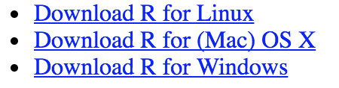

- Follow instructions for download and installation. I recommend installing the most recent version: R 3.5.3 “Great Truth” released on 3/11/2019. You must install a version of R at least as recent as R 3.0.1 (which dates back to 2013) in order to use RStudio.

Install R Studio
- Go to https://www.rstudio.com/products/rstudio/download/

- Click on download link for RStudio Desktop:
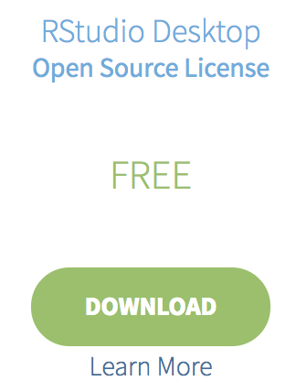

- Click on the installer link for your operating system:

- Follow instructions for download and installation.

